Name: D. Jayasree Course Code: ITA0330
Reg No: 192372129 Course Name: Mobile Computing

Experiment 1: Basic Cellular System Diagram in Figma

Aim: To create a diagram illustrating the components of a basic cellular system using Figma.

Procedure:
- Open Figma and create a new design file.
- Create a frame with a light-gray background.
- Draw five rectangular boxes and arrange them vertically.
- Add the names: Mobile Device, BTS, BSC, MSC, and External Networks.
- Give each box a different color.
- Connect the boxes using arrows to show communication.
- Add short descriptions inside each box.

Output:
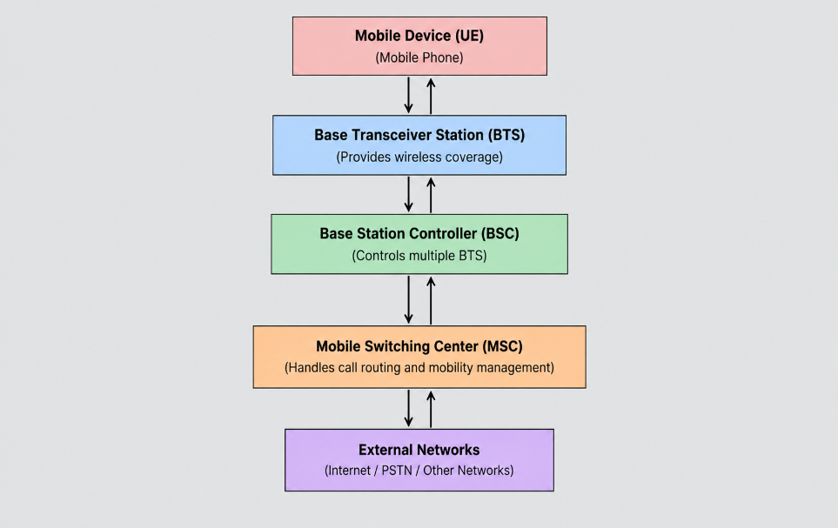


Result: A basic cellular system diagram was created successfully using Figma.

